# Potentiometer

A potentiometer is a variable resistor used to adjust voltage or signal levels in a circuit manually.

**Working Principle:**  
It has three terminals: two connected to a resistive track, and one connected to a wiper that moves across the track, changing the resistance and thus the voltage output.

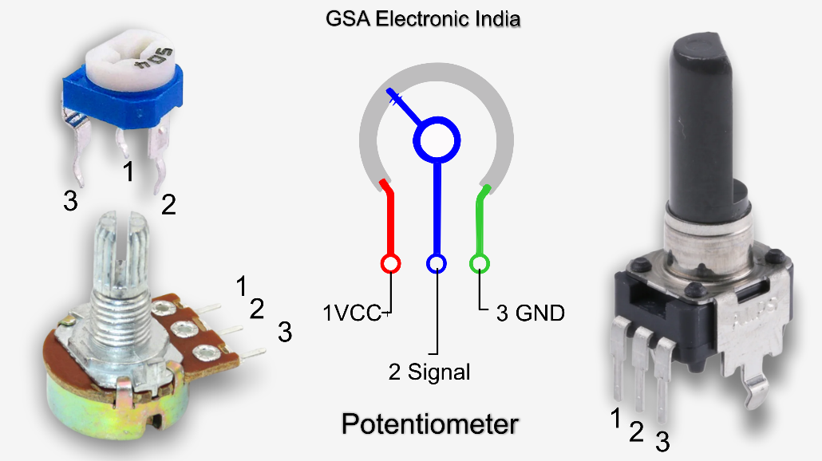

**Types**:  
- Rotary Potentiometer  
- Slide Potentiometer  
- Trimmer Potentiometer

**Applications**:  
- Volume control in audio devices  
- Sensor calibration   
- LCD brightness or contrast adjustment  
- Analog input for Arduino

**Advantages**:  
- Easy to use and adjust  
- Widely available  
- Simple analog control input

**Disadvantages**:  
- Mechanical wear over time  
- Not suitable for precise applications without calibration